UAT Plan

for

[CyberClimb]

Index

1. Scope 3

1.1. Objectives and business requirements 3

1.2. Scope 3

2. Testing team 4

3. Environmental requirements 5

3.1. Hardware requirements 5

3.2. Software requirements 5

4. Test Scripts 1

# Scope

## Objectives and business requirements

In this section, outline the business requirements. In other words:

* What are our goals? What are we hoping to accomplish with this project/feature?

The goal is to create a good design for a prosthetic arm to support Aaron so that he can get back rock climbing. That will make rock climbing and bushwalking easier and simpler for him. The primary objective of this prosthetic arm is to significantly improve Aaron's quality of life by allowing him to participate in his favorite activities, rock climbing and bushwalking.

* How will we measure success?

We will measure success by its functional performance, safety and satisfaction of Aaron.

## Scope

In this section, outline the scope. This means:

* What is the pain point we’re trying to fix?

The pain point we are trying to fix is to provide Aaron with a prosthetic arm.The prosthetic arm design project aims to provide a solution that allows him to participate in rock climbing and bushwalking again.

* What are we testing exactly, and what are we *not* testing?

We are testing how well the prosthetic arm is performing and how reliable it is. We are not testing how it assesses Aaron's climbing or bushwalking skills and the long-term durability.

## System Diagrams

In this section, paste any drawings or diagrams that help the UAT team understand the program being tested. With each drawing include a brief explanation of how the drawing represents the application or system being tested.

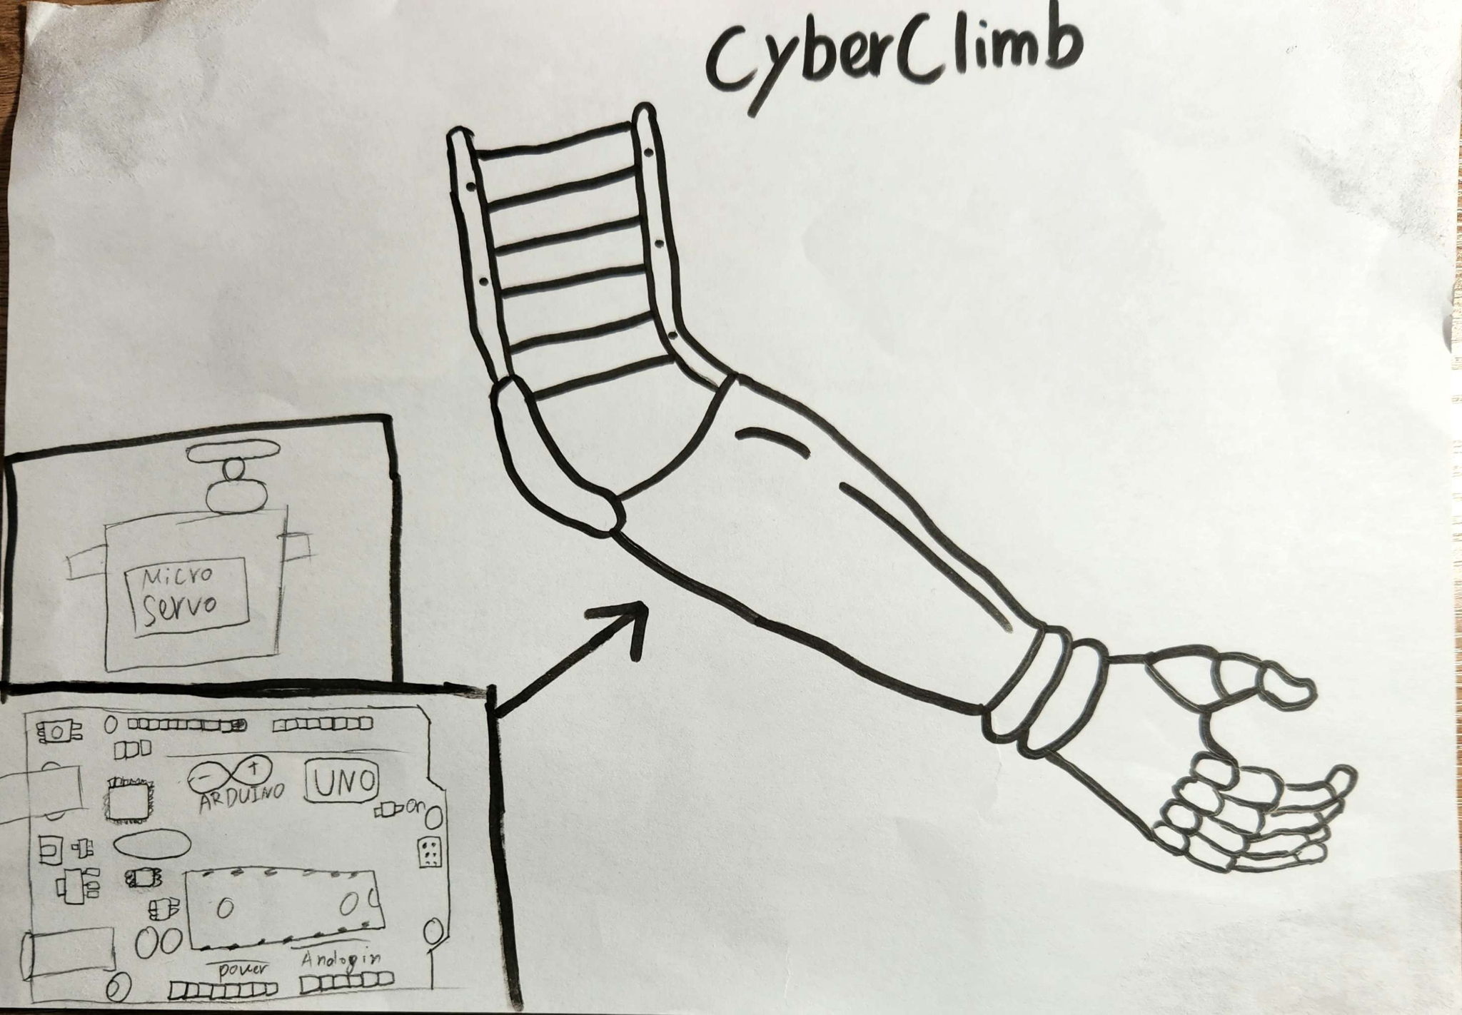

# Testing team

In this section, list out members of your QA team and what their roles will be during UAT.

| **Name** | **Responsibilities** |
| --- | --- |
| Ashton Chen | Test the durability and strength of the materials used in the prosthetic arm, to handle the pressures of climbing |
| Kelvin Aung | Verify that the power supply is reliable and safe. |
| Tam Cu | Verify that the sensors are providing reliable data. |
| Shafeen Chowdhury | Tested to see whether the final result is completely functioning and responsive. |
| Ismail Rizvi | Verify that the user can effectively operate and control the prosthetic arm during climbing. |

# Test Scripts

This section is more important than it seems—it is crucial that both the QA team and the testers know what features must be tested, especially if you’re testing a lot at once.

| **Test** | **Describe the feature being tested** | **Describe the user input or test data** | **Describe the pass criteria** |  |
| --- | --- | --- | --- | --- |
| 1.1 | The ability of the prosthetic arm | 1. User hold the device 2. User get close to obstacle | 1. Within 3 cm hand will be close 2. If obstacle >3 cm hand will be open | Tester name: Kelvin Aung   |  | PASS | | --- | --- | |  | FAIL |   Observations: |
| 1.2 | Ultrasonic ranger sensor measures distance | 1. When Ultrasonic Ranger sensor detects object within 3cm hand close and without 3cm hand open | 1. The hand will open when the obstacle to far 2. The hand will close when the obstacle within 3cm | Tester name: Shafeen Chowdhury   |  | PASS | | --- | --- | |  | FAIL |   Observations: |

Write step-by-step, detailed but concise instructions on how to test the feature.